Assignment front sheet
Learner name |  |  | Assessor name
 |  |  | Keeley Walsh
Date issued |  | Completion date |  | Submitted on
10th May 2013 |  | 17th May 2013
Qualification |  |  | Unit number and title
Edexcel BTEC Level 2 in Business |  |  | Unit 3 Financial forecasting for businesses
Assignment title | ASSIGNMENT 3 OF 4: CASHFLOW ANALYSIS

Criteria reference | To achieve the criteria the evidence must show that  the student is able to: |  | Task no. |  | Page numbers
P6 | prepare an annual cash flow  forecast using monthly data. |  | 1 |  | 3
M3 | analyse the implications  of regular and irregular cash  inflows and outflows for  a business organisation. |  | 2 |  | 3

Learner declaration
I certify that the work submitted for this assignment is my own and research sources are fully acknowledged.

Learner signature: Date:

Assignment brief
Unit number and title | Unit 3 Financial Forecasting
Qualification | Edexcel BTEC Level 2 in Business
Start date | 10th May 2013
Deadline | 17th May 2013
Assessor | Keeley Walsh
Assignment title | ASSIGNMENT 3 OF 4: CASHFLOW ANALYSIS
The purpose of this assignment is to:
Understand the use of a cash flow forecast.
Scenario

Following your break even analysis, your friend at Sarny Barmy is concerned that some months he will not make enough money to cover all of his costs. He has decided to speak to the bank about arranging a business overdraft to ensure that he has enough cash each month to pay for all of his commitments. He has asked you to help him work out when, and to what extent there may be cash flow issues, so that he has all the information he needs to speak to his advisor at the bank.

You are given the following projected sales and costs:

I’ve decide to reduce the price of a meal deal from March onwards to £2.75, hopefully this will improve demand as follows:
Units sold
Jan 1200
Feb 1450
Mar 1500
Apr 1600
May 1600
Jun 1600
Jul 1800
Aug 2000
Sep 1600
Oct 1600
Nov 1450
Dec 1300

- I’m going to do an advertising campaign in the Summer to get more customers in, so in May, June and July my advertising costs will increase to £100.
- The van’s MOT, and a full service are due in May and will cost £300. The tax is due in June and is £210, and I have to pay the insurance in August which is £450.
- Bob is moving out of the flat upstairs at the end of April, which is useful as I now need the space for storage, so there will be no rent coming in from May.
- I agreed to pay Dad back in two instalments of £950 in April and July

What do you think?
Harry

Task 1; Creating a cash flow forecast
P6; prepare an annual cash flow forecast using monthly data.

Using the projections that Bob has given you produce an annual cash-flow statement showing monthly cash inflows and outflows.

Task 2; Analysing the cash flow forecast
M3; analyse the implications of regular and irregular cash inflows and outflows for a business organisation.

Adjust your calculations and produce new cash flow statements to show the effect of the following:

  - Bob agrees to pay his dad back in 12 monthly instalments over the year.
  - Sandwich sales do not peak in Summer as expected but instead are fixed at 1605 each month

Using your new statements to help you illustrate your points, analyse the impact of regular and irregular cash inflows and outflows for Sarny Barmy, explaining what could happen to the business if cash going out of the business exceeds cash coming in.

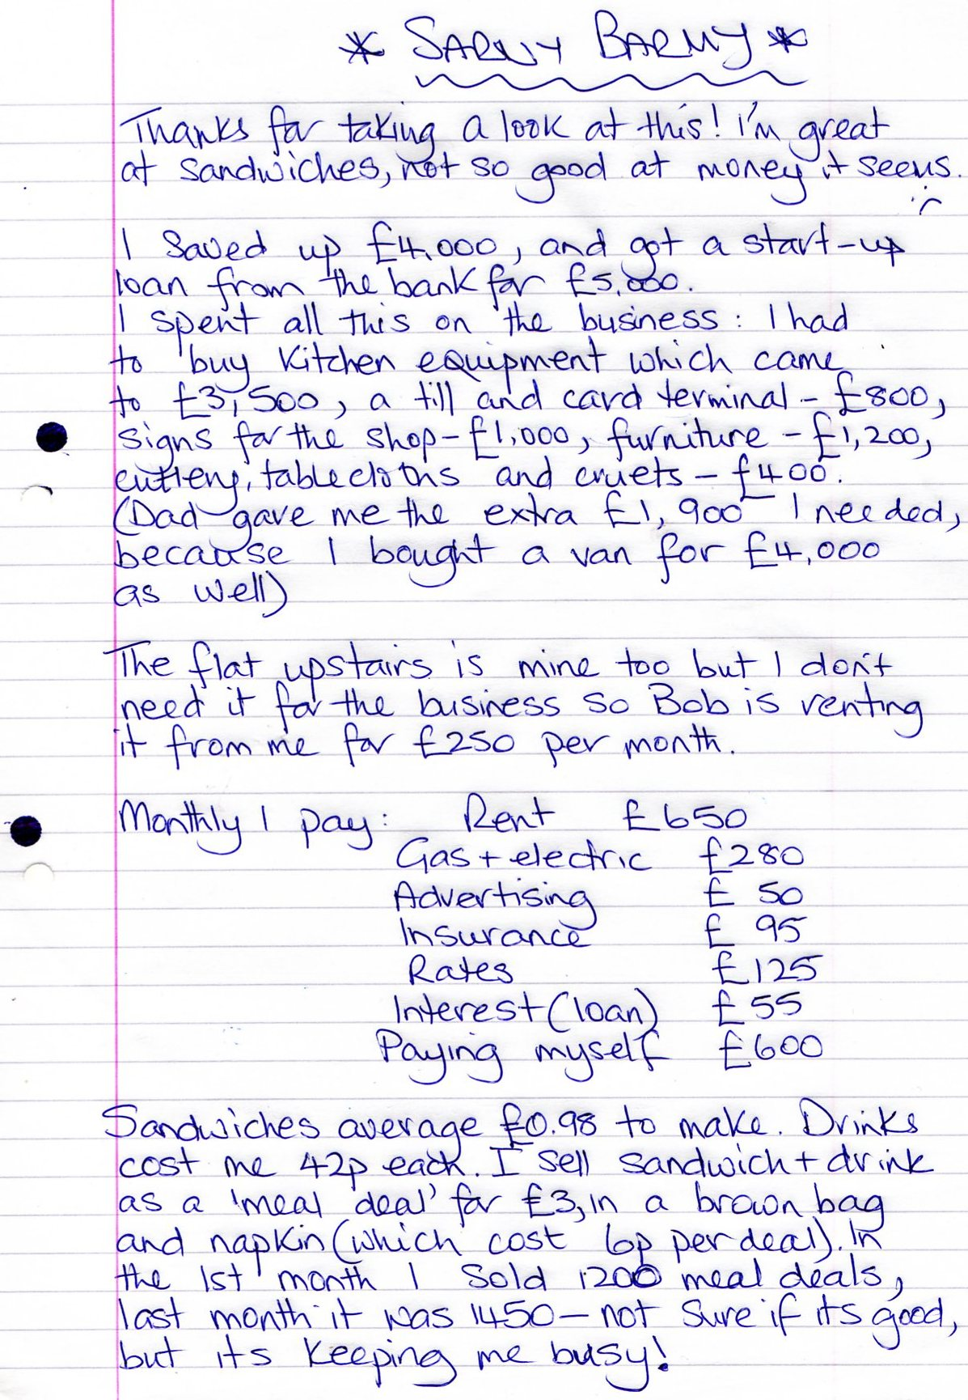
Sources of information

- BBC Bitesize
- BTEC Text book
- Bized.co.uk

This brief has been verified as being fit for purpose
Assessor | Keeley Walsh
Signature | K E Walsh | Date | 23/02/2013
Internal verifier
Signature |  | Date

Internal verification of assignment brief
Qualification
Unit number and title
Assessor
Internal verifier checklist |  |  |  |  | Comments
Are accurate programme details shown? |  |  | Y/N*
Are accurate unit details shown? |  |  | Y/N*
Are clear deadlines for assessment given? |  |  | Y/N*
Is this assignment for whole or part of a unit? |  |  | W/P
Are the grading and assessment criteria to be addressed listed? |  |  | Y/N*
Does each task show which criteria are being addressed? |  |  | Y/N*
Are these criteria actually addressed by the tasks? |  |  | Y/N*
Is it clear what evidence the learner needs to generate? |  |  | Y/N*
Are the activities appropriate? |  |  | Y/N*
Is there a scenario or vocational context? |  |  | Y/N*
Are the language and presentation appropriate? |  |  | Y/N*
Is the timescale for the assignment appropriate? |  |  | Y/N*
Overall is the assignment fit for purpose? |  |  | Y/N*
* If “No” is recorded and the internal verifier recommends remedial action before the brief is issued, the assessor and the internal verifier should confirm that the action has been undertaken.
Internal verifier
Signature |  |  |  | Date
Action required:
Action taken:
Assessor | Anjum Qureshi
Signature |  |  |  | Date
Internal verifier
Signature |  |  |  | Date

Assessor's comments
Qualification |  | Assessor name
Unit number and title |  | Learner name
Grading criteria |  |  |  |  | Achieved?
Learner feedback
Assessor feedback
Action plan
Assessor signature |  |  | Date
Learner signature |  |  | Date

Internal verification of assessment decisions
Qualification
Unit number and title
Assessor

Assignment title
Learner’s name
Which criteria has the assessor awarded? | Pass | Merit | Distinction
Do the criteria awarded match those targeted by the assignment brief? | Y/N  Details
Has the work been assessed accurately? | Y/N  Details
Is the feedback to the learner:  - Constructive?  - Linked to relevant assessment and grading criteria?  - Identifying opportunities for improved performance? | Y/N  Details
Does the grading decision need amending? | Y/N  Details
Remedial action taken
Confirm action completed
Assessor name | Anjum Qureshi
Assessor signature |  |  |  | Date
Internal verifier name
Internal verifier signature |  |  |  | Date

Observation record
Learner name
Qualification
Unit number and title
Description of activity undertaken (please be as specific as possible)
Assessment and grading criteria
How the activity meets the requirements of the assessment and grading criteria
Learner signature |  |  | Date
Assessor signature |  |  | Date
Assessor name

Witness statement
Learner name
Qualification
Unit number and title
Description of activity undertaken (please be as specific as possible)
Assessment and grading criteria
How the activity meets the requirements of the assessment and grading criteria,
including how and where the activity took place
Witness name |  |  |  | Job role
Witness signature |  |  |  | Date
Learner signature |  |  |  | Date
Assessor name | Anjum Qureshi
Assessor signature |  |  |  | Date

